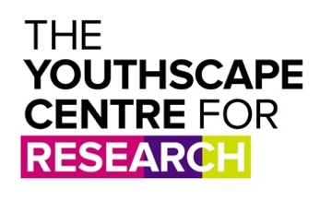
Translating God Information Sheet
for Young People

Who are you? | Hi, I’m Lucie Shuker, a researcher at Youthscape. Youthscape is a charity based in Luton that works with young people in our drop-in, in schools and in churches.  We also have a small research centre that does different projects, exploring questions we have about young people’s lives and how churches can help and support them. That’s where I work.
What is this research about? | The Christian faith has been around a long time, and throughout history the story of God has been translated, so that it makes sense to groups of people in different cultures, and with different languages.  We want to understand what it’s like to be a young person in 2022, and how the Christian faith might need to be translated once more, so that it makes sense to young people in their own culture.
What are you actually doing? | We are looking for groups of young people in different locations across the UK to take part in a discussion group - and that’s where you come in!  We’ve been told that you are someone who might be open to being part of one of these groups.
What would the focus group be like? | If you decide you want to take part, we would invite you to be part of a discussion. It will probably be with others from your youth group or young people you know. The focus groups will last for about 90 minutes (or 2 hours in person) with a short break in the middle. The questions aren’t too personal, but you don’t have to answer anything you don’t want to.  We’d be exploring what it’s like to be a teenager right now, the good, the bad, and everything in-between. We may run a follow up session as well, and get back in touch to see if you’re interested. But you don’t have to take part in that if you don’t want to.  The discussion will be audio recorded so we have an accurate record of what everyone says. But the research is anonymous, which means that if we use any quotes from you in our report we won’t use any real details about you, so no one will know that it was you.
What would you do with what I tell you? | We will use what you’ve told us to help us write a report which will help churches and youth workers to understand the world of young people better, and think about the language and stories they use to talk about the Christian faith. The researchers will listen to the recorded focus group and make written notes that will then be anonymised so the document has no personal details about you in it (for example, your name, where you live etc).  The document, the audio file and all other information with any personal data in it would only be accessible to the researchers, would be stored in a password protected file and won’t be used for any other purpose. After two years we will destroy this information.  If you decide to give us your email address, we will store this information securely and separately to the research data, and will only use it to update you about the research and send you the final research report. Once the project is finished, we will delete it.
Why should I take part? | People often find that talking to someone about their experiences and thoughts is quite interesting, and we hope it would be for you! As a thank you for taking part and spending time on this research, we will give each youth participant a £10 voucher for each session.  The research report will be used to develop new resources that help churches and charities develop new ways to support young people.
Anything else I need to know? | If you are 14 or 15, we will also be asking your parents if they are happy for you to be part of the project. If you are 16 or over, you can decide yourself.  Youthscape has a group of people who read our plans and documents, to check that the research is planned well, and won’t cause anyone harm or distress. But if we get it wrong and at any time you want to make a complaint about the research you can get in touch with Chris Curtis, who runs Youthscape, on 07973 147231 or chris.curtis@youthscape.co.uk.  Finally, you can tell us you don’t want to take part in the research at any point before 30th August 2022, by contacting lucie.shuker@youthscape.co.uk or texting me on 07595 504271. We won’t ask why, and will destroy any recordings or notes we’ve already made.

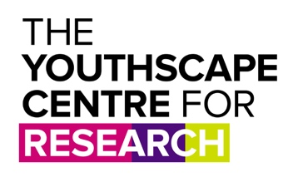

Consent Form for Young People

Please read the statements below. If you understand and are happy to agree to these, please tick each one, then write the date and sign your name at the bottom.

I have read and understood the information sheet.

I understand that taking part will mean taking part in a research discussion group that will last about 90 minutes

I don’t have to take part if I don’t want to, and can leave at any time without giving a reason
I understand that I can withdraw from the research at any time up until 30th August 2022 without giving a reason.

I understand that the recording and any notes from the focus groups will be stored securely and only be accessible to the researchers.

I am happy for the focus group to be audio recorded.

I understand that the content of the focus groups will be used to write a research report and other publications, and that if my words are used no one will know it was me who took part.

If you are happy to take part, please write your name, the date and sign below.

Name
Date
Signature
Email address

