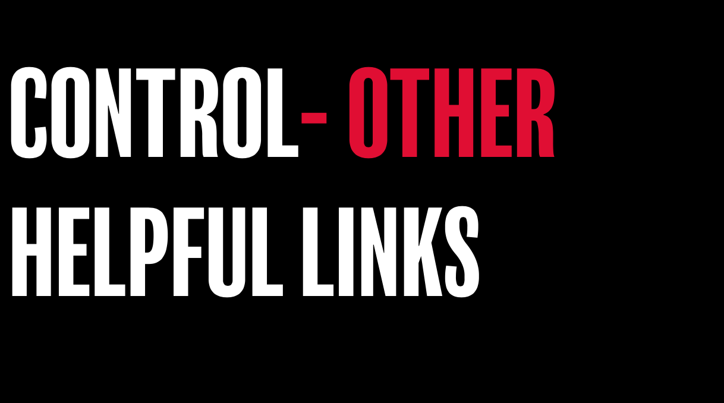

Here’s a few links that you may find helpful in continuing the conversation around this theme:

Online articles
https://www.tastelifeuk.org/get-help/about-eating-disorders/
https://www.beheadstrong.uk/stories/when-things-dont-go-as-planned
https://www.beheadstrong.uk/info/wantmore-about-eating-disorders
https://www.beheadstrong.uk/info/life-spinning-out-of-control
https://www.beheadstrong.uk/stories/escaping-the-control-of-anorexia-to-find-real-freedom
https://www.beheadstrong.uk/info/eating-disorders
https://www.beheadstrong.uk/info/dump-despair
https://www.beheadstrong.uk/stories/living-with-a-chronic-illness
https://www.beheadstrong.uk/stories/managing-anxiety-whilst-achieving-your-dreams

Helpful organisations
https://www.ataloss.org
https://www.tastelifeuk.org

