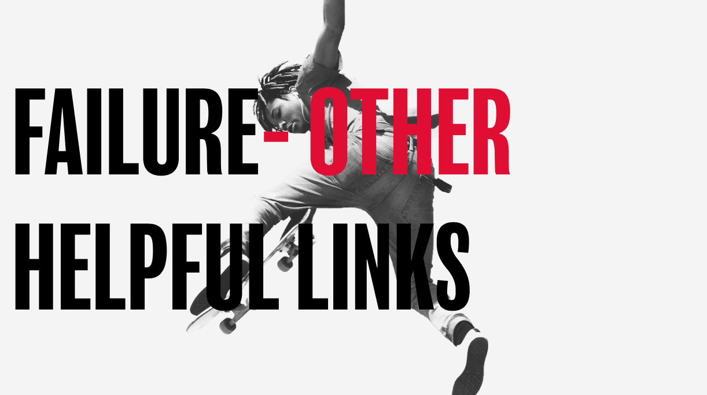

Here’s a few links that you may find helpful in continuing the conversation around this theme:

Online articles
https://www.beheadstrong.uk/info/blurgh-days
https://www.beheadstrong.uk/stories/dumped-and-devastated
https://www.beheadstrong.uk/stories/shoplifting-and-grace
https://www.beheadstrong.uk/stories/plans-fall-apart

Helpful organisations
https://www.ataloss.org
https://www.tastelifeuk.org

