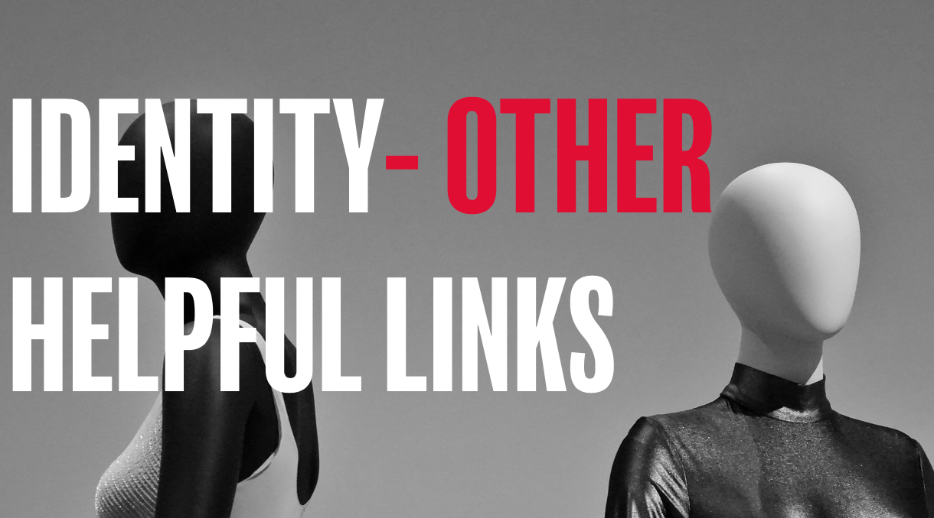

Here’s a few links that you may find helpful in continuing the conversation around this theme:

Online articles
https://www.beheadstrong.uk/stories/identity-and-social-media
https://www.beheadstrong.uk/stories/being-yourself-at-school
https://www.beheadstrong.uk/info/wantmore-identity
https://www.beheadstrong.uk/stories/things-you-thought-you-had
https://www.beheadstrong.uk/stories/learning-to-love
https://www.beheadstrong.uk/stories/learning-to-say-yes
https://www.beheadstrong.uk/stories/haha-and-hehe
https://www.beheadstrong.uk/info/wantmore-identity-1
https://www.beheadstrong.uk/info/wantmore-identity-1-1
https://www.beheadstrong.uk/info/wantmore-identity-2

Helpful organisations
https://www.ataloss.org
https://www.tastelifeuk.org

