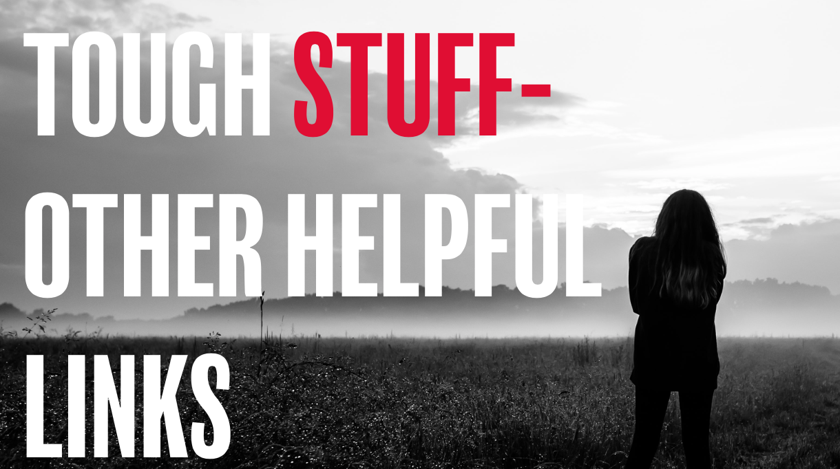

Here’s a few links that you may find helpful in continuing the conversation around this theme:

Online articles
https://www.beheadstrong.uk/info/all-about-anxiety-part-1
https://www.beheadstrong.uk/info/all-about-anxiety-part-2
https://www.beheadstrong.uk/info/all-about-anxiety-part-3
https://www.beheadstrong.uk/stories/when-things-dont-go-as-planned
ttps://www.beheadstrong.uk/info/wantmore-about-self-harm
https://www.beheadstrong.uk/info/want-more-about-panic-attacks
https://www.beheadstrong.uk/stories/drawing-your-feelings
https://www.beheadstrong.uk/stories/guys-this-ones-for-you-3-things-you-can-do-to-turn-a-bad-day-around
https://www.beheadstrong.uk/stories/guys-this-ones-for-you-releasing-anger
https://www.beheadstrong.uk/stories/guys-this-ones-for-you-lets-talk-comparison
https://www.beheadstrong.uk/info/friendship-problems
https://www.beheadstrong.uk/info/trouble-sleeping-1

Helpful organisations
https://www.ataloss.org
https://www.tastelifeuk.org

